Date | Note
2025-09-04 | Installation of the PV Blocks System  - Module imec 1 mounted
2025-10-09 | Mounting structure put up for the two other modules (components missing, MC4Y connectors)
2025-11-10  afternoon | Mounting of module imec 2 & imec 6  - imec 2: large module (underneath module imec 1)  - imec 6: small module  [picture 1]
2025-11-18 | - Previously only forward scan was measured. Changed to forward/reverse Isc-Voc-Isc for hysteresis effect detection  - set tilt angle of SiRef to 37 degrees (previously 45 degrees)
2025-12-01 | Cleaned module imec 2 from dirt that covered several cells to a small extent. Effect on IV curve?

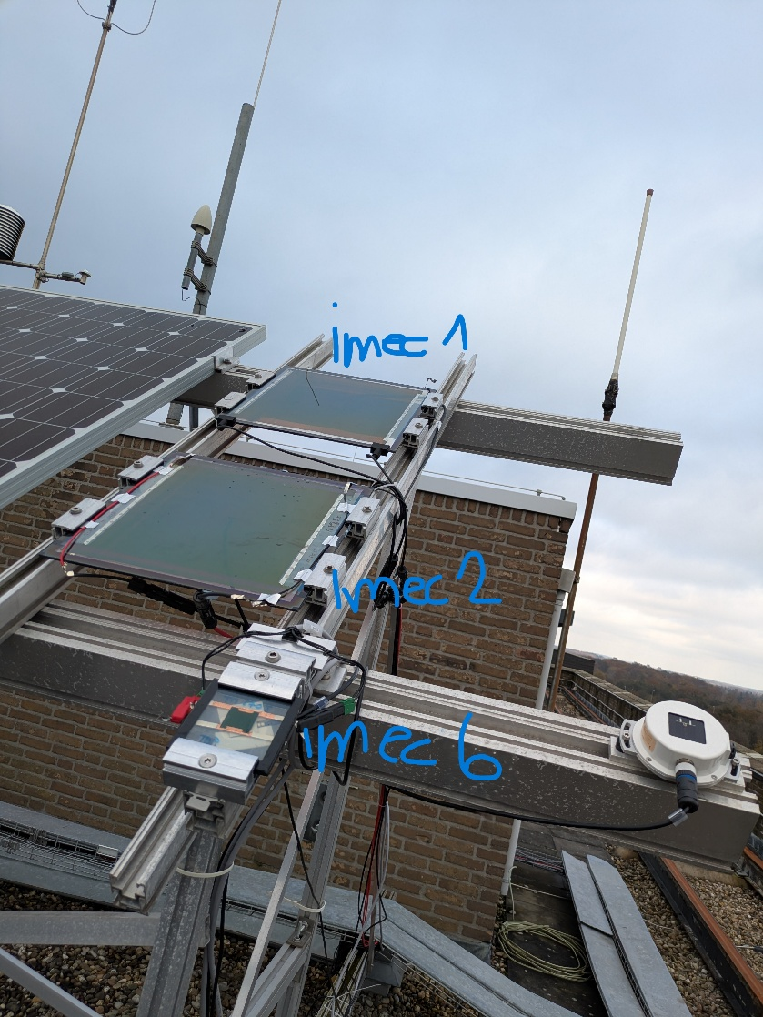
Picture 1

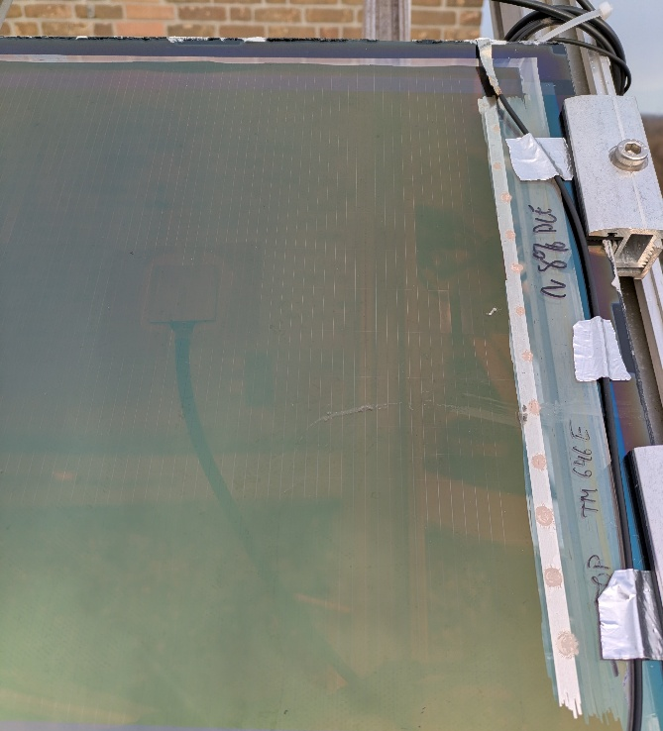
Dirt on imec 2 that was removed

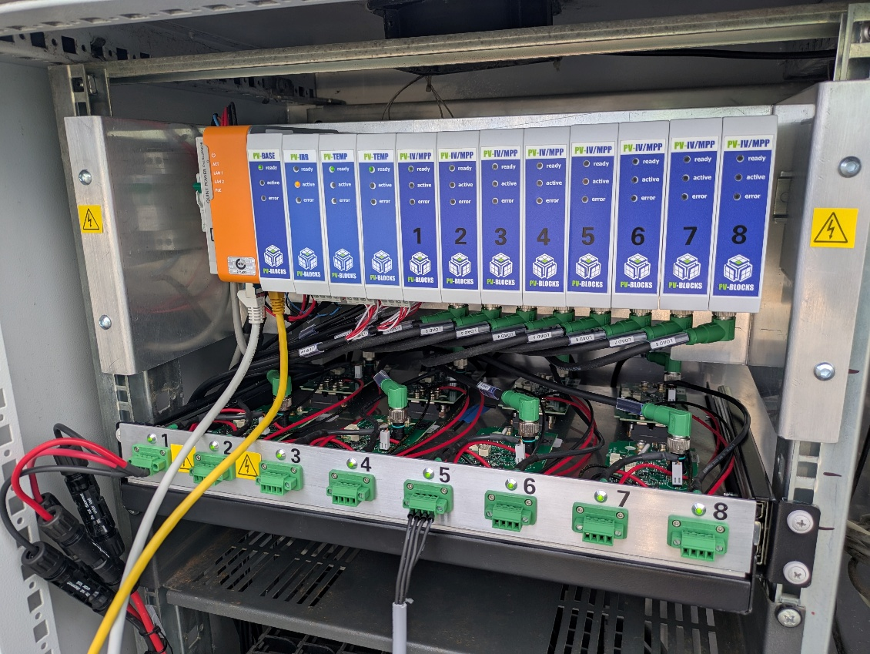
Monitoring System (PV Blocks)

